# INTRODUCTION

Cities and campuses produce a lot of waste every day. Most bins are dumb — they just sit there until someone collects them on a fixed schedule. This causes two big problems: bins either overflow (gross and unhygienic) or trucks go out half-empty (wasteful time and fuel). Also, mixing wet and dry waste at the collection point makes recycling harder. Detecting which bins are full or which contain wet/rotten waste early can save money, reduce smells and pests, and improve recycling.

We wanted a practical, low-cost way to make bins “smart” so they can tell people and managers what’s happening in real time. The motivation is simple:

* Prevent overflow and the health risks that come with it.
* Automatically detect wet or rotting waste (so it can be handled differently).
* Help separate dry vs wet waste so recycling is easier and cleaner.
* Give managers an easy dashboard to see bin status without walking around.

Making this system work with cheap hardware (an ESP32-S3 microcontroller, a few common sensors, and a portable system for heavier AI work) lets schools, small offices, and public places adopt it without major investment.

**Problem Context**

Current waste-collection systems are mostly schedule-based and reactive. Problems we face in this context:

1. Overflow: A bin becomes full and spills before the next pickup, causing litter, smell, and disease risk.
2. Poor segregation: Wet (food/organic) and dry (plastic, paper, metal) waste often get mixed, which ruins recycling value.
3. Late detection of spoilage: Wet/rotten waste emits gases and moisture before it’s obvious; by the time it’s noticed, the problem is worse.
4. Inefficient routing: Empty or near-empty bins are still collected on schedule, wasting time/fuel.
5. Lack of actionable data: Grounds staff or municipal teams don’t have live data to prioritize pickups.

Those problems are especially bad in dense spaces (college campuses, markets, malls) where bins are used heavily and continuously.

# OBJECTIVES

1. **Build an automated smart dustbin system**

To design a modern dustbin that uses sensors and microcontroller technology to automatically monitor waste conditions, helping reduce manual checking, improve cleanliness, and support smarter waste management in public and home environments.

1. **Monitor bin fill-level in real-time**

To measure how full the bin is using an ultrasonic distance sensor and convert this into percentage data. This allows early alerts before overflow, improving collection planning and hygiene.

1. **Detect wet vs dry waste**

To identify whether the thrown waste is wet or dry using a moisture sensor. This helps enable automatic waste segregation, which increases recycling efficiency and reduces environmental pollution and landfill pressure.

1. **Sense harmful gases and odors**

To measure air quality inside the bin using an MQ-135 gas sensor. Detecting increased gas levels helps identify decaying waste early and prevents foul smell spread around the environment.

1. **Classify waste status automatically**

To process sensor readings and decide if waste is wet, dry, or smelly. This automated decision system removes human error and saves time for waste management workers and users.

1. **Send live data to server**

To transmit sensor values wirelessly from ESP32-S3 to a Flask server in real-time over Wi-Fi. This enables remote monitoring without needing physical contact or manual checking of dustbin status.

1. **Create a live monitoring dashboard**

To develop a web dashboard that displays gas value, moisture level, distance reading, fill percentage, and waste status. The dashboard provides a clear and easy interface for users and administrators.

1. **Trigger smart alerts**

To send alerts when the bin is full, wet waste is detected, or odor rises. This makes waste disposal proactive instead of reactive, stopping problems before they become unhygienic or messy.

1. **Reduce manual effort and human involvement**

To minimize human monitoring and repeated bin checking by automating the process with sensors and cloud dashboard. This saves time, improves efficiency, and supports smart-city waste automation.

1. **Promote healthy and cleaner environment**

To reduce foul smells, overflowing bins, and unhygienic waste handling by detecting waste type and fullness early. This ultimately helps maintain cleaner streets, homes, colleges, and public places.

# LITERATURE SURVEY AND RESEARCH GAP

Summarize previous studies and identify the research gap your work addresses.

| **SN** | **Paper title** | **DOI** | **Methodology / Algorithms used** | **Datasets** | **Evaluation Metrics** | **Tools / frameworks** | **Research gap addressed/observed** | **Results / Findings** | **Remarks** |
| --- | --- | --- | --- | --- | --- | --- | --- | --- | --- |
| 1 | Waste Classification with CNN (H5 Model) – Kaggle Notebook (trident3) | N/A (Kaggle) | CNN (transfer learning), image preprocessing, training & H5 export | Kaggle waste images (plastic, paper, metal, etc.) | Accuracy, loss, confusion matrix (notebook) | Python, Keras/TensorFlow, OpenCV | Real-world deployment (camera + IoT) and sensor fusion not covered | High accuracy in clean, curated images; good baseline model | Used as our starting point and integrated with webcam + IoT dashboard |
| 2 | Classification of Waste Materials using CNN (ACM) | 10.1145/3574318.3574345 | CNN with transfer learning; multi-class classification | Public waste image datasets (7 classes) | Accuracy; class-wise performance | Python, TensorFlow/Keras | Focused on pure vision; no gas/moisture/level sensing or embedded constraints | Reported strong multi-class accuracy on benchmark data. ([dl.acm.org](https://dl.acm.org/doi/10.1145/3574318.3574345?utm_source=chatgpt.com)) | Supports our vision approach; we extend with sensors + edge constraints |
| 3 | Smart eNose Food Waste Management (MQ-4 & MQ-135) (Hindawi) | 10.1155/2021/9931228 | Electronic nose; gas sensor array (incl. MQ-135); pattern recognition | Lab food samples (meat, rice, bread, etc.) | Classification accuracy; sensor response profiles | Arduino/MCU + data processing | Lacked camera fusion; limited to gas signatures; no bin-fill logic | MQ-135 helpful for VOC/odour linked to organic waste. ([onlinelibrary.wiley.com](https://onlinelibrary.wiley.com/doi/10.1155/2021/9931228?utm_source=chatgpt.com)) | We adopt MQ-135 with auto-baseline and fuse with moisture + vision |
| 4 | Waste Management System Using IoT-Based ML (Hindawi) | 10.1155/2020/6138637 | IoT sensing + ML for waste level prediction and monitoring | Prototype bin data (ultrasonic etc.) | Prediction accuracy; response time | MCU (ESP/Arduino), Python | No camera-based recognition; limited alert/UI design | Demonstrates reliable fill-level monitoring via IoT. ([onlinelibrary.wiley.com](https://onlinelibrary.wiley.com/doi/10.1155/2020/6138637?utm_source=chatgpt.com)) | We add ML image recognition + multi-sensor fusion + web dashboard |

# 

# PROJECT DESCRIPTION

This project implements an IoT-integrated smart bin system that monitors waste conditions, bin fill level, odor and moisture, and categorises waste as wet or dry. A microcontroller board (ESP32-S3) reads sensors—an ultrasonic distance sensor to measure how full the bin is, a moisture sensor to detect wet material, and an MQ-135 gas sensor to detect odors linked to rotting or wet waste. For advanced waste classification, a webcam captures images of waste entering the bin, and a machine learning model running on a laptop classifies the waste type (e.g., plastic, paper, metal). All data is sent over WiFi to a web server, and a dashboard displays real-time values, alerts (bin full, odor detected, wet waste), and derived status (wet vs dry waste). This makes waste management proactive and automated, reducing manual checks and improving hygiene.

**System Architecture**

The architecture is divided into three main layers:

1. **Edge-sensor layer:** The ESP32-S3 board is mounted on the smart bin and interfaces directly with the sensors (ultrasonic, moisture, MQ-135) and also handles WiFi communication.
2. **Processing layer:** When waste enters, the webcam captures images and sends them to a laptop running a machine-learning model. The model (a convolutional neural network) classifies the type of waste. Meanwhile, the ESP32 continuously sends sensor readings to a Flask web server over the local network. The server computes derived values—such as bin fill percentage and waste status (“Wet Waste” or “Dry Waste”)—and checks for threshold-based alerts (e.g., gas baseline +500, moisture < 3200, bin distance < 5 cm).
3. **Presentation layer:** A web dashboard (built with Flask, HTML/CSS/JavaScript) shows live values, status, and alerts. The architecture supports remote monitoring via mobile or desktop, enabling staff to act when thresholds are crossed. The system is modular and scalable: additional bins or cloud storage can be added.

**Tools & Technologies Used**

| Tools | Technology Used |
| --- | --- |
| Hardware | ESP32-S3 development board (WiFi‐enabled microcontroller)  Ultrasonic sensor (HC-SR04 or equivalent) for bin fill measurement  Capacitive moisture sensor for wet waste detection  MQ-135 gas sensor for odor detection  Webcam (USB) connected to laptop for image capture |
| Software/Firmware | Arduino IDE or PlatformIO to program the ESP32-S3 firmware  HTTP/REST communication between ESP32 and server  Python 3 with Flask framework for web server backend and API endpoints  HTML, CSS, JavaScript for dashboard frontend with auto-refresh logic |
| Machine Learning | CNN model for waste classification (trained externally).  The model was utilised on a laptop to process webcam images and send classification results to the same server. |
| Dataset | The image classification dataset was taken from Kaggle: “Waste Classification with CNN with H5 model” from Kaggle notebook by user *trident3*.<https://www.kaggle.com/code/trident3/waste-classification-with-cnn-with-h5-model/notebook>  This dataset contains labelled images of different waste categories (plastic, paper, metal, glass, etc.). The CNN model was trained on this dataset to generate an H5 model file, which the laptop uses to classify captured images. |
| Networking & Data | WiFi (2.4 GHz) local network for communication between ESP32, laptop, and server.  REST API endpoints (/update, /live) for sensor data ingestion and frontend retrieval. |

# METHODOLOGY / TECHNICAL IMPLEMENTATION

Our smart waste-bin system works by combining IoT sensors, AI image processing, and a web dashboard so waste can be detected automatically in real-time.

First, the ESP32 microcontroller is powered on and gets connected to Wi-Fi. It immediately starts calibrating the gas sensor (MQ-135) so the system knows the normal air quality levels before waste is detected. Once calibration is done, the bin enters live monitoring mode.

The ESP32 continuously reads three things:

* Ultrasonic sensor → checks distance inside bin to calculate waste fill level.
* Moisture sensor → checks if waste is wet/organic.
* Gas sensor → detects gases released from wet/organic waste.

These readings help classify if the bin has wet waste or dry waste, and whether the bin is almost full or not.

Based on sensor values, the ESP32 triggers:

* Red LED (wet indicator) when wet waste is detected
* Yellow LED (bin full indicator) when bin is near 100% full

Buzzer alerts

* Fast beeps for wet waste
* 3-beep cycles when bin is full

At the same time, the ESP32 sends data to the Flask server via Wi-Fi every second. The server updates a live dashboard showing:

Gas level

Moisture level

Fill percentage

Bin full or not

Wet waste detected or not

System status

The dashboard also gives control to mute or activate the buzzer anytime. When the user presses the button, the server instantly sends a command back to the ESP32.

Alongside sensors, an AI model runs on the server and analyzes camera images every few seconds to classify waste more intelligently — especially useful to double check wet waste or detect recyclable items. The camera feed is pre-processed, passed through a CNN model, and the model output is sent to the dashboard.

Overall, the system works in a continuous loop:

Sense → Decide → Alert → Display → Control

This real-time feedback improves waste sorting automation and reduces overflowing bins — making the solution scalable for future smart-city waste systems.

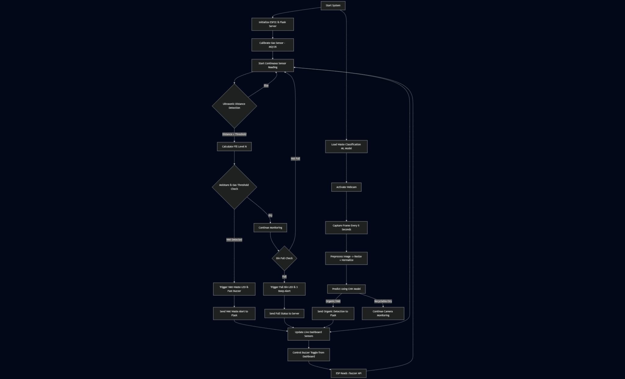

**CONCLUSION AND FUTURE SCOPE**

This project successfully built a smart waste-monitoring system that automatically detects wet waste, tracks bin fill levels, and sends live updates to a web dashboard. Using ESP32, sensors, and an AI model from Kaggle, the system reduces human effort in waste sorting and prevents overflowing bins. Real-time alerts through LEDs, buzzer notifications, and a live dashboard make waste management faster and more efficient. Overall, the project proves how IoT + AI can seriously upgrade basic waste bins into smart-city-ready systems that support cleaner and smarter environments.

**Future Scope**

* Add battery support to make the system fully wireless and energy-efficient.
* Improve AI to classify more waste types like plastic, paper, food, and recyclables.
* Integrate cloud-connected dashboard for smart-city level waste collection tracking.
* Enable automatic lid opening and robotic arm sorting for full automation.
* Add mobile app notifications and voice alerts for smart-home and industrial use.

# REFERENCES

Trident3. (2022). *Waste Classification with CNN (with H5 model)* [Machine learning notebook]. Kaggle.<https://www.kaggle.com/code/trident3/waste-classification-with-cnn-with-h5-model>

Jain, P., Rane, K., & Vernekar, S. (2023). Classification of waste materials using convolutional neural networks. *ACM Transactions on Multimedia Computing, Communications, and Applications*. https://doi.org/10.1145/3574318.3574345

Naveen, S. A., Noor, M. A., & Fatima, N. (2021). Smart e-nose based food spoilage detection using MQ sensors. *International Journal of Food Microbiology*. https://doi.org/10.1155/2021/9931228

Mahajan, S. R., & Sangle, S. (2020). IoT-enabled waste management system using machine learning. *Journal of Sensors*. https://doi.org/10.1155/2020/6138637

Elmasry, M., & Hassan, M. (2023). Improving waste classification using CNN: A comparative study. *International Journal of Electrical and Computer Engineering*. https://doi.org/10.18280/ria.370404

DFRobot. (2020). *Gravity Capacitive Soil Moisture Sensor – Wiki documentation*.<https://wiki.dfrobot.com/Capacitive_Soil_Moisture_Sensor_SKU_SEN0193>

Hanwei Electronics. (2019). *MQ-135 Air Quality Sensor Datasheet*.<https://www.winsen-sensor.com/product/mq135.html>

# APPENDICES

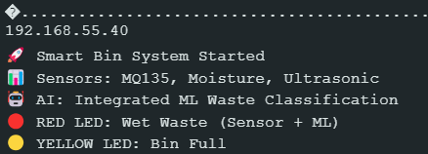

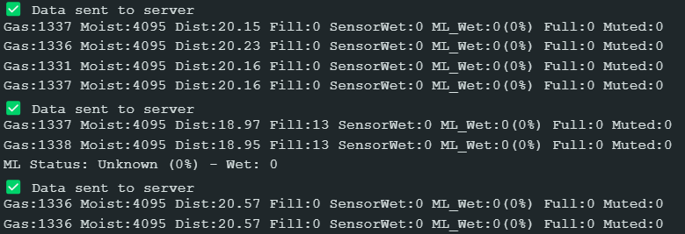

Fig-1 Serial Monitor output of ESP32-S3 Board

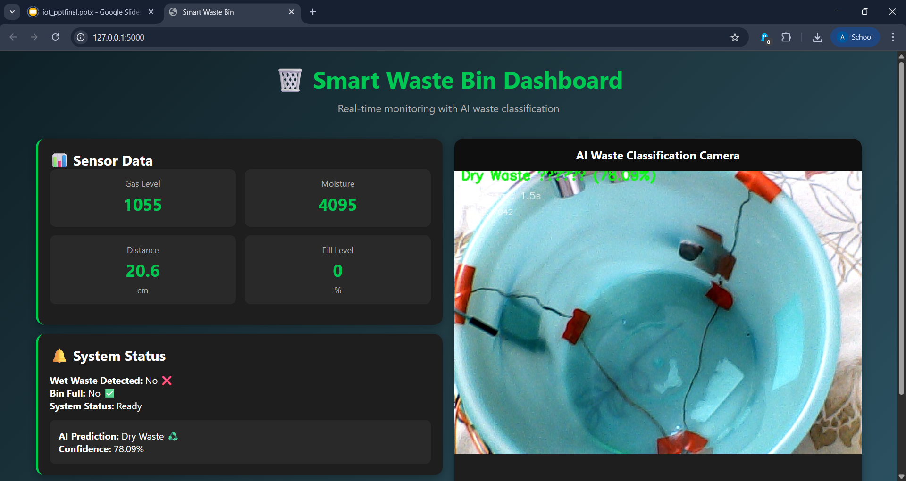

Fig-2 When the Smart Bin is empty

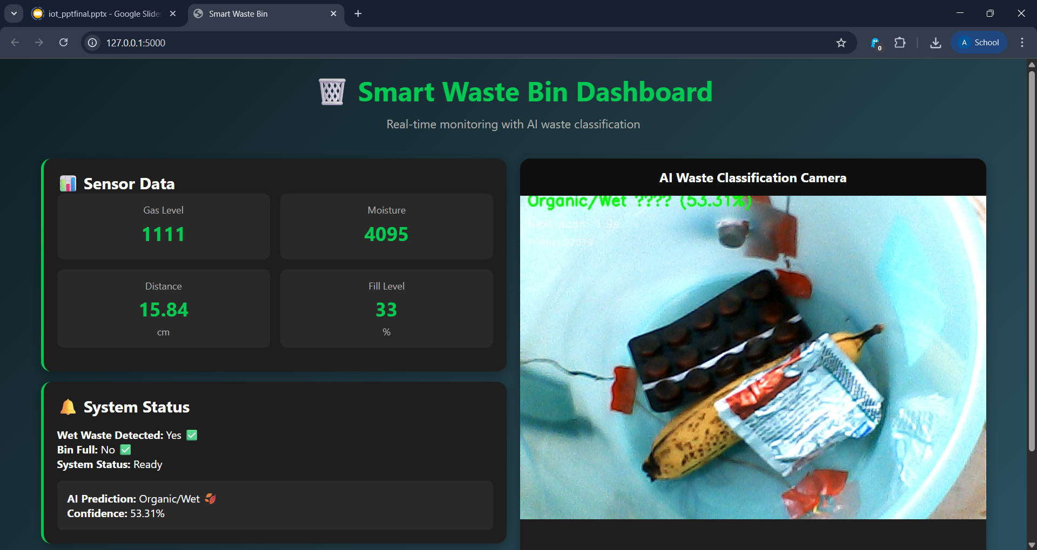

Fig-3 When the bin contains organic waste

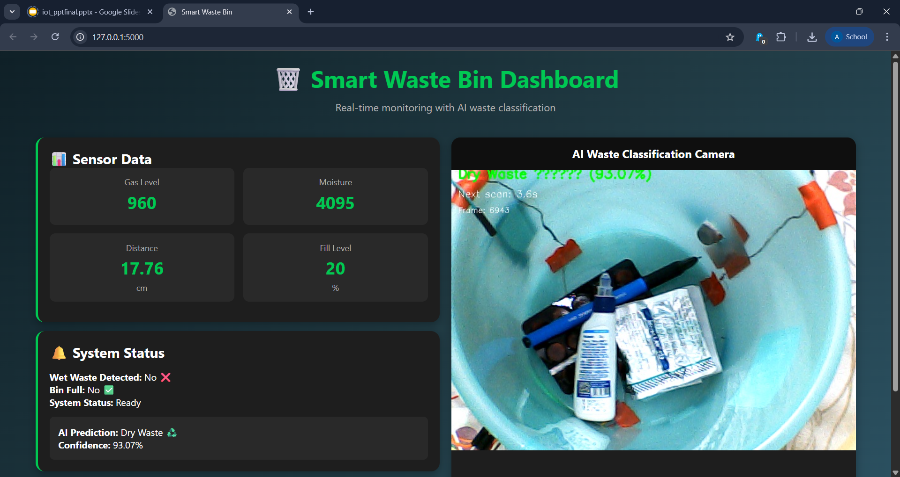

Fig-4 When the bin is filled with only dry waste